Rabbi Pinkhas Halevi Komisaruk

Born 1830, Rassein (now Raseiniai), Lithuania.
Died 26th Adar Rishon, 5697/1897 Grafskoy, (now Prolotarsky), Ukraine

Son of Rabbi Shlomo-Zalman Halevi (1798-1853) and Yokhved Komisaruk.

Great-Great-grandson of the Vilna Gaon.

Husband of Khaya-Sarah Levin (1834-1873)

The fact that Pinkhas was born in Rassein was established by the discovery of a history of where Pinkhas appears in the category of notables who were born in Rassein but lived elsewhere. This source also identifies his maternal grandfather and his father Shlomo Zalman. Indeed had it not been for the discovery of this book, the family's connection with Rassein might never have been known and the family's earlier history never uncovered, as oral tradition told of the family's origin as Kovno (Kaunas). This referred to the province of Kovno in which the city Rassein was located.

A brief biography appears in the history of Rassein:

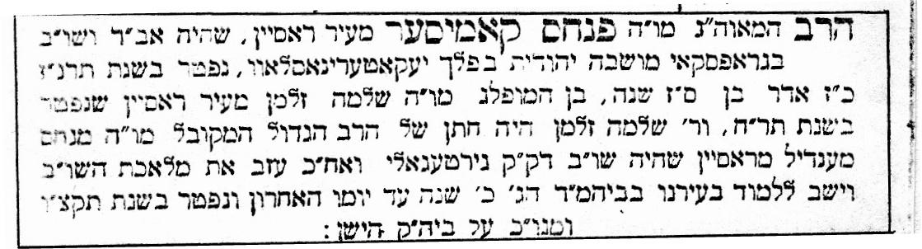

"The rabbi, the great luminary, our teacher the Rabbi PINKHAS KOMISAR from the city of Rassein, who was Av Din and Shokhet in Grafskoy, a Jewish colony in the Government of Yekaterinoslav, died in the year 5657, (1897) 27th Adar, aged 67. Son of our outstanding teacher Rabbi Shlomo Zalman from the city of Rassein who died in the year 1848. Reb Shlomo Zalman was the son-in-law of the great Rabbi, the Kabbalist, our teacher Rabbi Menakhem Mendel from Rassein who was Shokhet in the Holy Community Girtegola and afterwards left the labour of Shekhita and sat learning in our city in the Great Beit Midrash 20 years until his last day and died in 5596 (1836). His honourable resting place is in the old cemetery."

There are several errors in this information. Rabbi Shlomo Zalman did not die in 1848 but in 1853 in Grafskoy. The error may have been made by the author of "Ir Rassein" who found no further reference to Shlomo Zalman in Rassein after 1848, by which time he had emigrated from the city.

Rabbi Pinkhas obtained his rabbinic learning initially in Lithuania and from his father. He was also trained as a Shokhet. Following the death of his father in 1853, the religious leadership of the colonies was thrust upon him at a young age. Despite the promised exemption from military services, when the Crimean War broke out in 1854 Rabbi Pinkhas was conscripted. He served in the supply corps and thereby was able to care for the dietary needs of the Jewish troops by obtaining live cattle for Shekhita. Even in the confusion of battle Rabbi Pinkhas sought out Jewish troops for prayer and dedicated himself to comfort the wounded and bury the dead.

Upon his release from the army Rabbi Pinkhas took up farming his share of the family allotment together with his brothers. He toiled in the fields by day and studied and taught by night. Only when his sons were old enough to take over was he free to act as full time Rabbi.

Grafskoy 1890 census Komisaruk family

1. Family #15

2. Head of Household
Komisaruk Pinkhas Zelmanowich.
The elder has additionally two sons, who are not living in the colony;
one daughter is married;
one of sons has three boys.
3. Housing
Goverment provided house covered with thatch (bad state). Near it built a new house with two rooms also covered with thatch (Good state).
Stable also covered with thatch

4. Equipment
two ploughs, one and two furrow.
One mangle.
One harrow.
Two Britchka (carts).

5. Animals
five horses
Three cows.
One calf.
6..
Land holding:
Except 1/3* of land [10 desyatins of father's 30], also rents 17 desyatins. 2/3 of land owned by older brothers.

7. Farmed by Himself
8.. Quality of farming. Good

Whilst following the Lithuanian system of interpretation of religious law, Rabbi Pinkhas always took into account the needs of his people, seeking to ease any economic burden on poor families. If a poor woman brought a chicken to him to check whether it was Kosher, if there was only a small doubt, he would allow it. If the person was wealthy, he would decide on the strict side of the law and ban the chicken.

Aside from rabbinic duties Rabbi Pinkhas was also a Mohel. The Mariupol synagogue records list three circumcisions performed by Pinkhas in 1885 and one in 1894.

During the pogroms of the 1880's Rabbi Pinkhas was renowned for his selfless dedication to helping the suffering. Whenever news arrived of a pogrom he rode off to tend the wounded and conduct funerals for the victims. During his army service he had learnt the rudiments of medical care and acted as a "Feldsher" (medical orderly) since qualified doctors rarely were available to tend the Jews. Rabbi Pinkhas was a Feldsher so during one Yom Kippur he interrupted services in the synagogue in order to give medical aid to a sick woman.

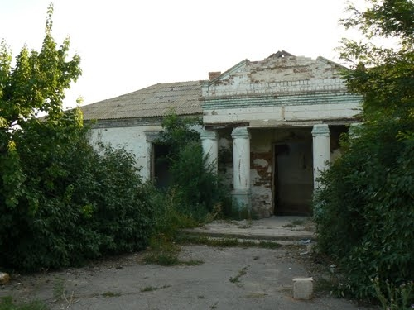
Grafskoy Synagogue in ruins 2010

Having lost his wife in childbirth he remarried twice since tradition required the Rabbi of a community to be married. Rabbi Pinkhas met an untimely death contracting pneumonia after falling into his well whilst trying to draw water to
feed the animals.
. 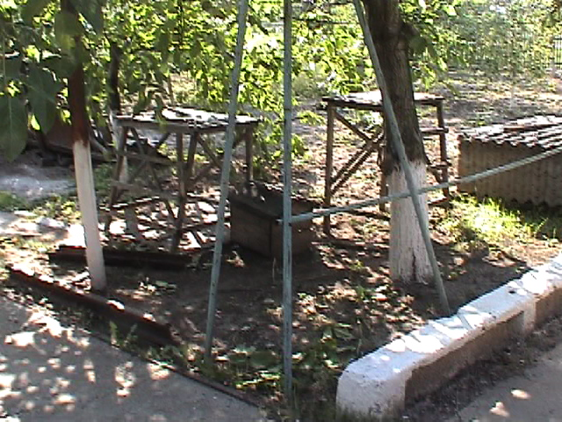 Well in Grafskoy 1999

This was indicative of his concern for others since, although no longer involved in farming, he decided to save the family the trouble of rising early in the cold winter and took upon himself the task.

His funeral was long remembered by people who came from the colony regions. Thousands attended, including sixteen Rabbis from the district who had come to pay homage to this renowned scholar and devoted leader. Stories of Rabbi Pinkhas' activities were related by the following generations and this author remembers listening to his grandparents relate the tales of their beloved grandfather.

Rabbi Pinkhas' obituary appeared in the Hebrew newspaper Hamelitz:

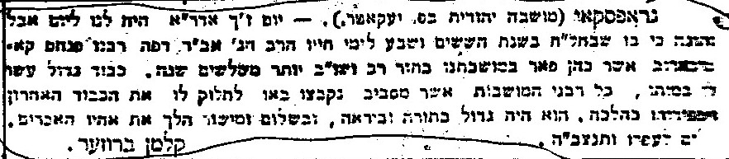

"GRAFSKOY: (a Jewish colony in the Government of Yekaterinoslav). - the 27th day of Adar Rishon was for us a day of mourning and grief because on it departed to his eternal life in the sixty seventh year of his life, the great Rabbi, Av Din of this place, our Rabbi Pinkhas Komisarov who officiated to the glory of our colony in the position of rabbi and Shokhet and examiner more than thirty years. Great honour was shown him upon his death, all the Rabbis of the surrounding colonies gathered and came to pay him their respects and to eulogize him according to the law. He was great in Torah and Fear of Heaven, and in peace and honesty led his brethren the farmers. Peace be to his dust and may his soul be bound up in the bond of everlasting life. Kalman Bruser."

(The author of this obituary, Kalman Bruser, was a son of David Moshe Bruser whose family also originated in Rassein and settled in Grafskoy.)

Whilst Rabbi Pinkhas left no written record of his scholarship, several books which belonged to him were saved from destruction during the revolution, and these bear his signature. A treasured memento of him is in daily use by this author: his Tefilin which were inherited by his grandson Shlomo Zalman Komesaroff (Kaye) of Melbourne and in turn by this author.
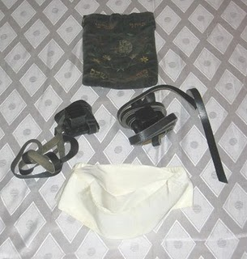

Pinkhas's grandson Mordekhai (Mottel/Mark), a son of Rabbi Zalman Komisaruk of Vasilkovka, mentions his grandfather in his memoirs:

"The first of our ancestors who I remember was my father's father, the grandfather Pinkhas, by him there were three other brothers, of whom I only knew the great-uncle Velvel. Other brother, that means my great-uncles with the names Yaakov and Zalman, I did not see. One of them was in Kovno, and the grandfather Pinkhas and the great-uncle Velvel lived in a Jewish colony in Yekaterinoslav Government, Mariupol district. The colony was called Grafskoye, or No. 7 (all 17 colonies which were situated in Yekaterinoslav Government had a number). The grandfather Pinkhas was a Shokhet and a Rabbi, and his sons, that means my uncles, father's brothers, worked the earth like peasants and the great-uncle Velvel with his sons Berel and Meir also initially worked the land, only later did Berel opened a small store, and Meir was living by the work of the land.

When I was 6 years old I remember that they brought to grandfather Pinkhas a painted tree with branches, the tree began with the great-grandfather who was called Mendel. From there it went to his sons Pinkhas, Velvel, Yaakov and Zalman. Only in my memory remains only the grandfather Pinkhas with his four sons Shlomo Zalman (this was my father) with his brothers Mendel, Simkha and Meir. What I am writing about is only the roots which came out from the grandfather Pinkhas with his brother Velvel. (On the tree were only male people)."

There are several errors, namely that Pinkhas's father was not Mendel, but Zalman and Pinkhas had another brother who lived in Grafskoy, Leibl.

"We came to colony Grafskoy, there did the grandfather Pinkhas live, the grandfather Pinkhas I remember that he always used to go around with a black scarf tied to his cheek, I don't know the reason. He was an angry Jew. The parents went away to the village Vasilkovka, Pavlograd district, and I remained living in the colony learning from the Gemorah Melamed. I used to “eat kest” by uncle Simkha, and the brother by the uncle Mendel. The grandfather Pinkhas used every Shabbat to hear us, and never was he satisfied. He used to say it was a waste of the fees paid for our lessons. Later I wanted to travel home and I remember that Uncle Mendel harnessed his horse and a droshky and on Sukkot we came home"

Mottel's impressions of his grandfather Pinkhas are in sharp contrast to others of his cousins, particularly Mendel's son Zalman and Meir's daughter Khana-Reizel (later married and lived in Melbourne, Australia. They spoke of their grandfather Pinkhas with great affection. Mottel's attitude was perhaps a forerunner of his later revolt against traditional Shtetl education to the exclusion of any secular study. Indeed he was representative of many of his generation who yearned to be part of the open secular Russian society, restricted as it was in many ways to Jews.

Rokhel Luban (daughter of Avrom Hillel and Dina Namakshtansky) wrote about her maternal grandfather in her memoirs:

"Grandfather Rabbi Pinkhas didn't live very long. It was a cold winter. Grandfather did not want to wake the children so they could give food and water to the horses and cows. He got up and dressed warmly. In the barn he gave them all food. But they wanted to drink. He took the bucket with a rope out to the well to draw water. It was very slippery; it was a heavy frost and in the evening when they had drawn water from the well, some spilt out. As it was a very cold night, it froze and became very slippery. It was impossible to stand properly as Grandfather lowered the bucket and filled it with water. When he pulled up the bucket, it pulled him over into the well.

He began shouting for help. They couldn't find a rope. Everyone was so confused that they couldn't think clearly. In the same house with Grandfather lived Grandfather's brother (# Velvel) and he had a shop for farmers' supplies. But there was no rope. Grandfather called from the well:" You stand in the middle of the ocean and you ask for a drop of water.

When they pulled him out of the well they quickly brought a doctor. But he was too chilled and they could not save him. Seventeen rabbis from the surroundings came to the funeral. All the children from the places where they lived, together with many householders, came to pay their respects for the father.

For my mother it was the worst. When she was born and lost her mother, Grandfather used to sit all night with the Gemorrah in his hand (# studying), swinging the cradle. My mother knew how to `Pasken' all the `Sheylahs' (# make decisions of religious law)."

Rabbi Pinkhas' signature in a book 1884

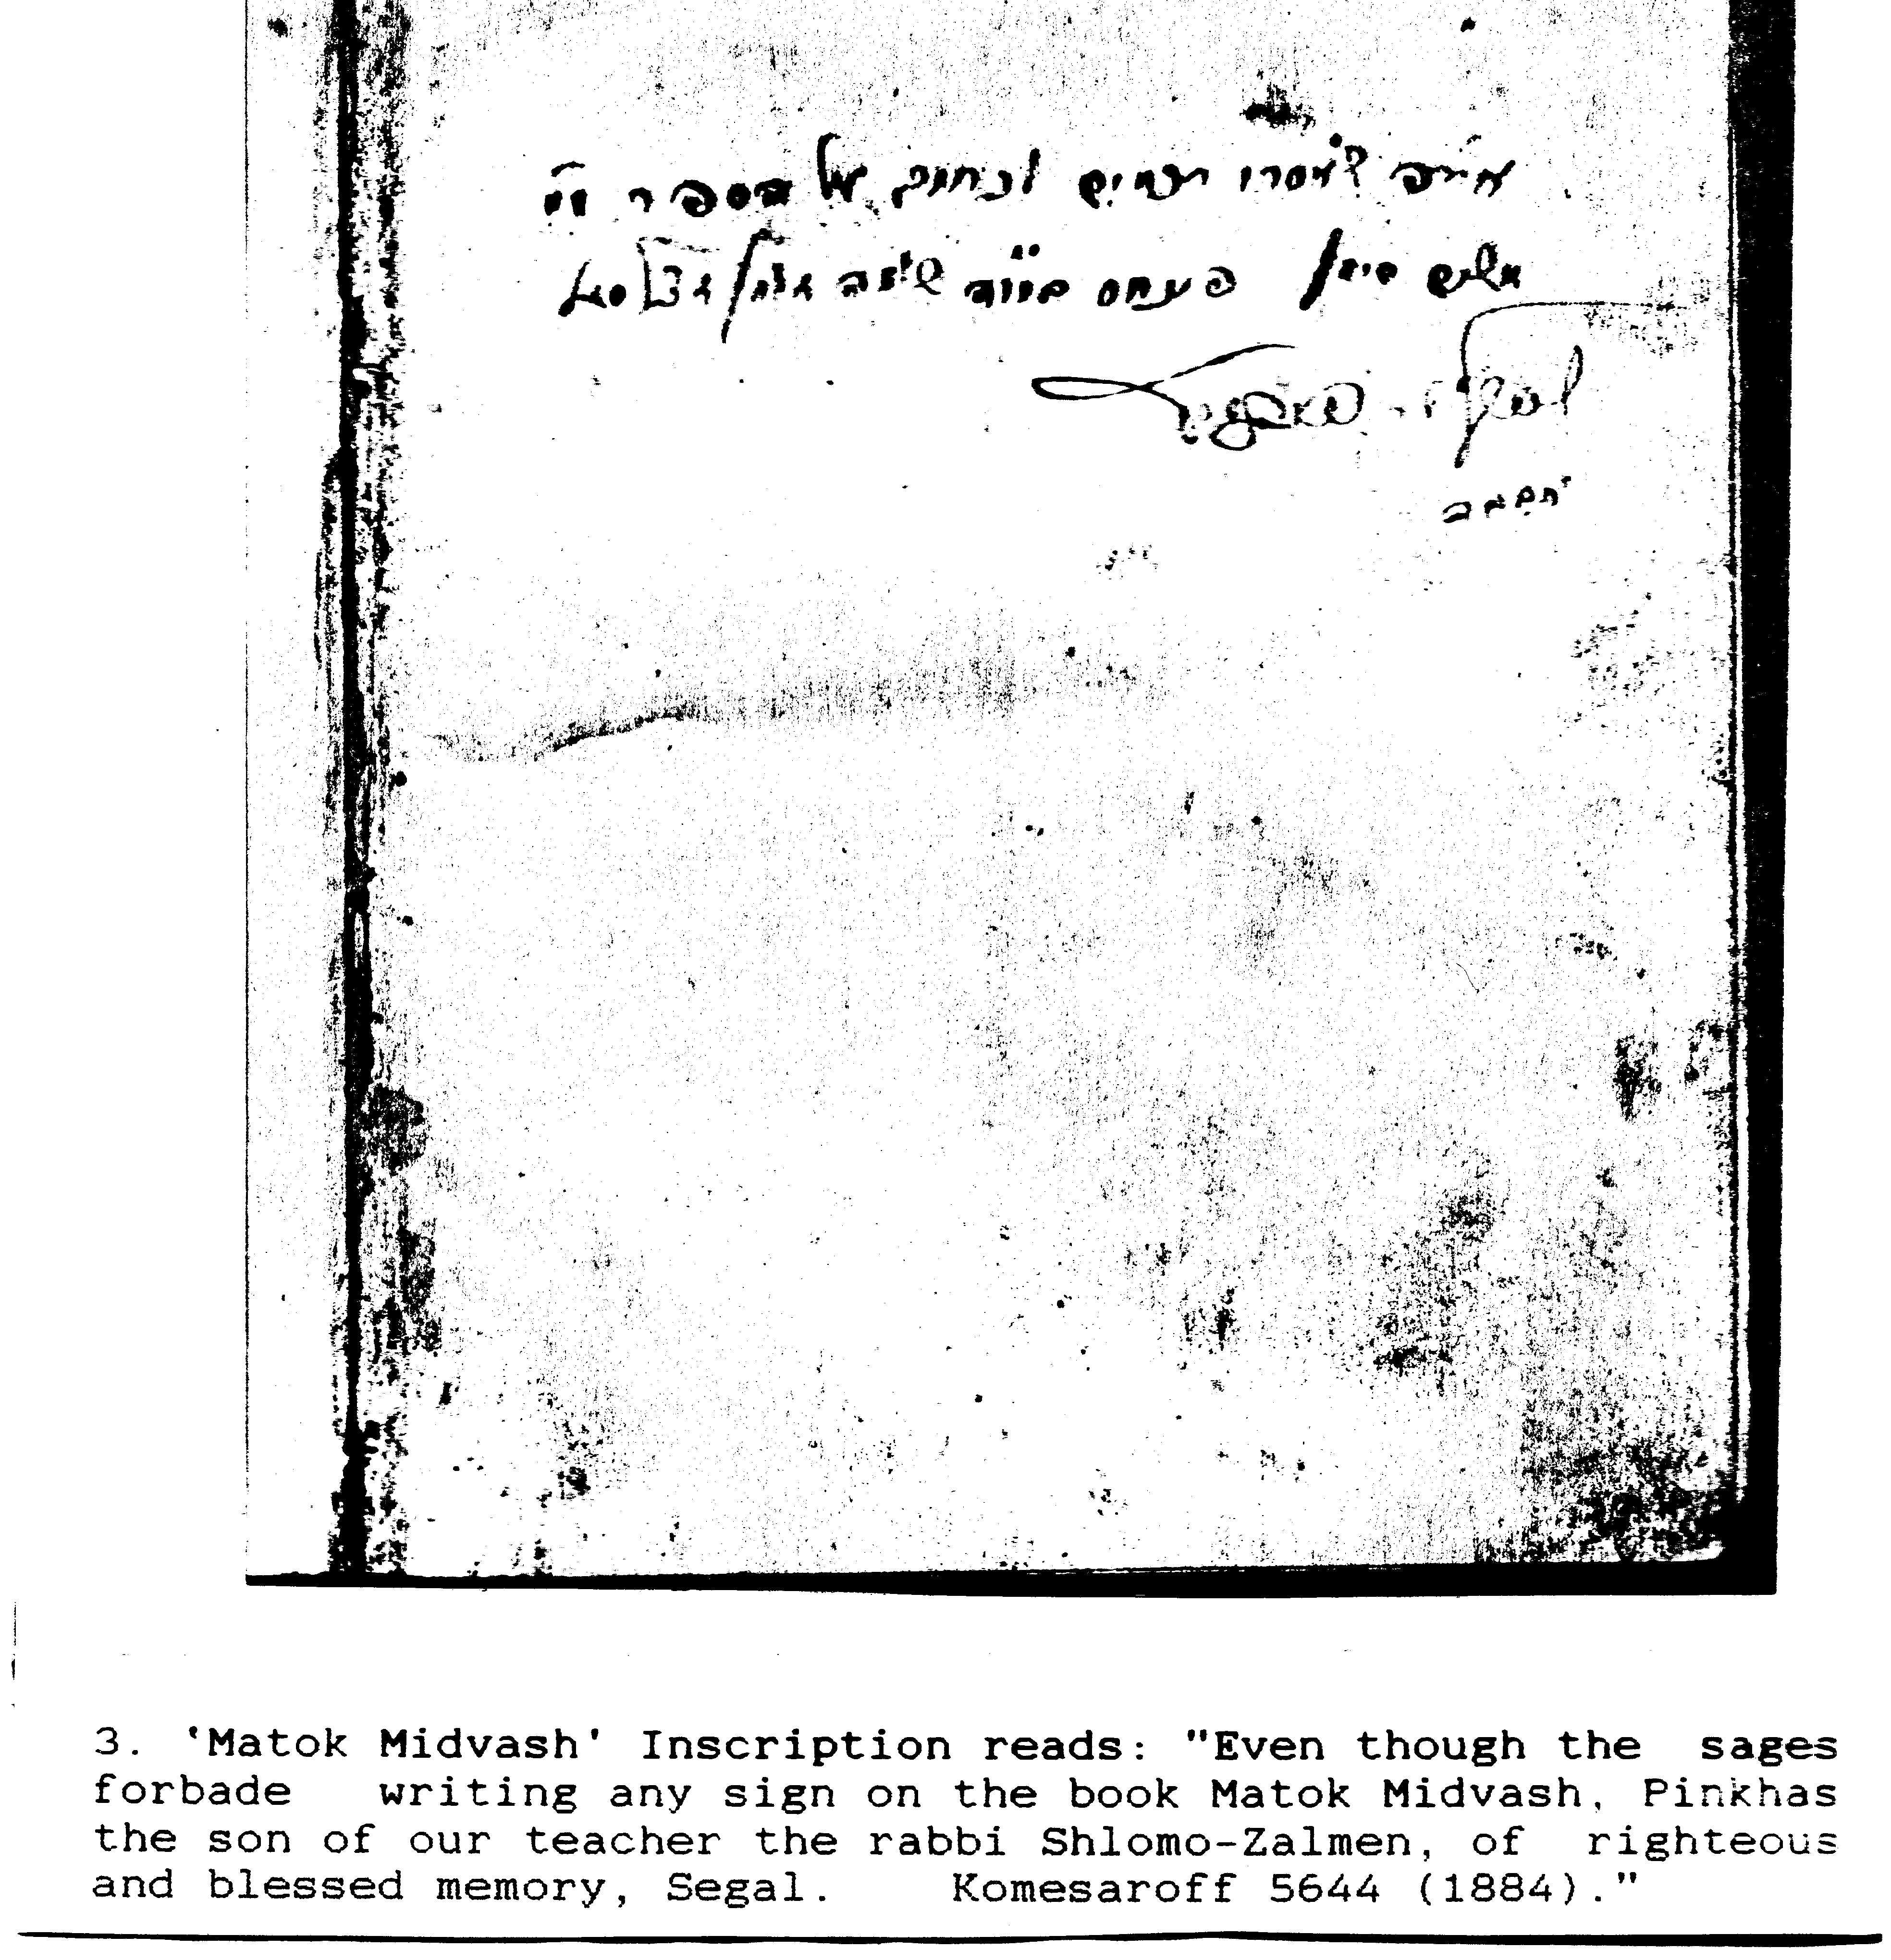

Rabbi Pinkhas' signature Grafskoy mayor election 1861

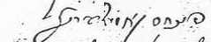

"Lekorot Ir Rassein Urabbaneiha" M.arkowitz, Warsaw 1913
ibid
Peter Kaye (Komesaroff), Melbourne, Australia.
"Jewish Agricultural Colonies in Ekaterinoslav Province in 1890", L. Uleinikov [Binshtok], St Petersburg, 1891,
Clara Berchansky as related by her mother Rokhel Luban (nee Namakshtansky). Petah Tikvah, Israel
William Kaye (Komesaroff, son of Zalman), Melbourne, Australia.
Orlinsky, Ukraine album http://www.panoramio.com/user/3366156
Mel Comisarow, Vancouver, Canade, while visting the colonies.
Literal translation from Russian and Yiddish. Memoirs provided by Joseph Komissarouk, USA.

