This is a fragment from the history of
Gorodok public library
Establishment.

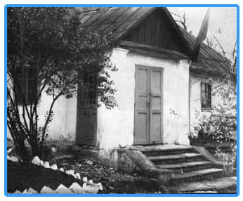

During the 1920th the first spark of education and culture was ignited in Gorodok.
In 1927, in a small shack in town, where currently a restaurant operates, a reading room was established.
The reading room was run by Kleyman Isaac Borisovich and his assistant Novikov Klara (Novik Klara was murdered by the Nazis in Yarmolintsy)

In a shed/ reading room operated Komsomol School and studies were conducted by Studnyk – the principal of the Jewish school.
He was a very smart, intelligent and talented man and has assisted in the establishment and organization of libraries in the region.
In 1937 Studnyk was repressed by the Stalin regime.
In 1941, with the outbreak of the WWII, the library was ruined.
The library was renovated in 1944 and relocated to Grushevsky st.63.
Translated by Marc Goldberger


